**Lesson 1.2. Create a Network from Scratch and Run Dynamic Traffic Assignment**

**1.2.1 Data Sets**:

<https://github.com/xzhou99/learning-transportation/tree/master/Lessons/Lesson%201/Lesson%201.2/Data%20Set>

**Other resources**: Chapter 3.3: Network Data: [NCHRP Report 716](http://www.trb.org/Main/Blurbs/167055.aspx): Travel Demand Forecasting: Parameters and Techniques, which is an update to NCHRP Report 365.

**1.2.2 Learning Objectives:**

1. Path travel time is the sum of link travel time along routes

2. Signal timing could lead to time-dependent traffic delay

3. A large number of MOEs available for comparing scenarios

**1.2.3 Background:**

|  |
| --- |
| **Foothill** in [Salt Lake City, Utah](http://en.wikipedia.org/wiki/Salt_Lake_City,_Utah) is a relatively affluent and primarily residential neighborhood of Salt Lake City that lies at the base of the Wasatch Range and extends west to approximately 1500 East.  The neighborhood takes its name from the area's major traffic artery of Foothill Drive (State Route 186), which runs parallel to the base of the mountains and connects Interstate 80 with the University of Utah and downtown Salt Lake City. The University of Utah sits at the north end of this neighborhood. Points of interest include the Hogle Zoo, Red Butte Garden and Arboretum, This Is The Place Heritage Park, Fort Douglas Military Museum and the Foothill Village Shopping Center. Source: <http://en.wikipedia.org/wiki/Foothill,_Salt_Lake_City> |

|  |  |
| --- | --- |
|  | A transportation network is used for traffic analysis to determine the flow of vehicles, congestion level and other performance measures. |

This assignment will require users to create a transportation network from scratch, using a background image as a reference. The network to be created includes a number of links, nodes and zones, and users also need to modify an origin-to-destination demand table to generate vehicles for traffic assignment. Two assignment methods, namely static traffic assignment and dynamic traffic assignment, are used to produce link volume, speed and other measures of effectiveness (MOEs).

**The following tasks will be carried out.**

**Task 1:** Create new project folder

**Task 2:** Create nodes and links for transportation network modeling

**Task 3:** Become familiar with GIS-layer based context menu

**Task 4:** Create zones and map activity locations

**Task 5:** Create Demand Data for Traffic Simulation

**Task 6:** Define a path and check path travel time

**Task 7:** Run static traffic assignment and find path travel time

**Task 8:** Check Link MOE

# Step 1: Create new project folder

**Step 1.1:** First, click on the data-set of Foothill Corridor Network. Copy the entire folder Sample_Foothill_Corridor and paste it at the same place which will create a Sample_Foothill_Corridor – Copy. Now, open the copy folder and delete all the files except ‘Foothill Corridor.tnp and background_image.bmp’. Next, rename the folder to ‘New_project_with_background_image’. With the empty project file and the background image file, we will be able to create a transportation network from the scratch. The data set folder consists of four different folders out of which the ‘Sample Data Set’ folder is for students to practice after they understand this lesson. ‘Sample Project Files’ folder consists of demand files and input_scenario_settings file which will be used in this lesson for running simulation.

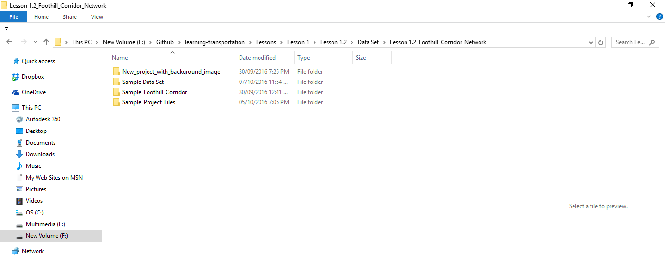

|  |  |  |
| --- | --- | --- |
|  | File name | Simple descriptions |
| 1 | Foothill Corridor.tnp | Foothill Corridor project file |
| 2 | background_image.bmp | Background image file in bitmap format |
| 3 | input_demand_type.csv | Input file that defines characteristics for different demand types for the trips in input_demand.csv |
| 4 | input_demand_file_list.csv | Input file that defines the characteristics of demand data such as demand loading start time and end time, loading multiplier, number of demand types stored in demand file, etc. |
| 5 | Input_demand.csv | Input file showing demand of number of trips |

Open the new project folder 🡪 open the Foothill Corridor.tnp with notepad 🡪 Select the entire text and delete 🡪 Save (file 🡪 save) 🡪 Now open NeXTA 🡪 From file, click open traffic network project 🡪 Open the Foothill Corridor.tnp from the New_project_with background_image folder.

Thus the new tnp file loaded on NeXTA is entirely blank.

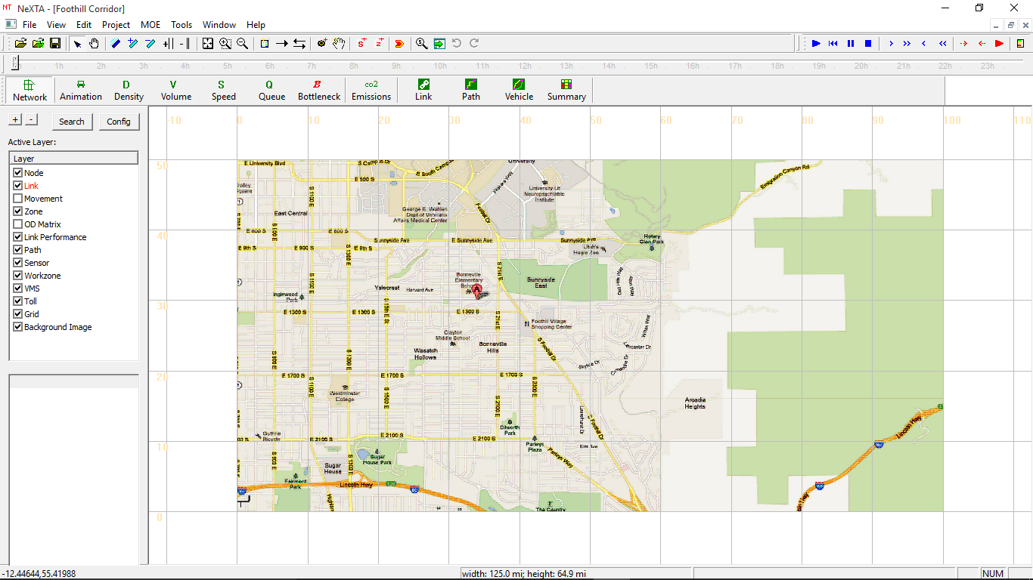

Currently, NEXTA only supports bitmap file type. Users can also screen-capture another background image from Google Maps or other sources.

**Step 1.2:** Click the 'background' layer on the GIS layer panel, the corresponding layer becomes red when this layer is selected. Check or uncheck this layer to show the corresponding data items on the display view.

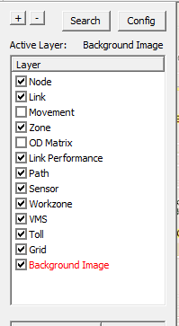

**Step 1.3:** This step involves adjusting the background image to its correct spatial length, width, and orientation using known locations within the image. In order to make this adjustment, we need to create two reference points in the image, find their corresponding long/lat coordinates, and then reposition/scale the image to the commonly used lat/long format using a tool in NeXTA. Adjusting the background image in this way should improve the spatial accuracy of the image, and if we use the background image to draw new network components (like links and nodes for roads), those newly-created links should be more accurate (e.g., the link distance can be calculated using the lat/long coordinates with better accuracy).

**Please follow the steps below for adjusting the background image:**

(i) Make sure the “background image” GIS layer is selected (as shown in the image above).

(ii) Right-click at a known location on the background image and select "Mark point A" to locate the first point. We suggest a point with a well-defined location, such as an intersection (500 South and 1300 East is a good choice, as shown below) - the middle of a park or city block is more ambiguous and may be less accurate.

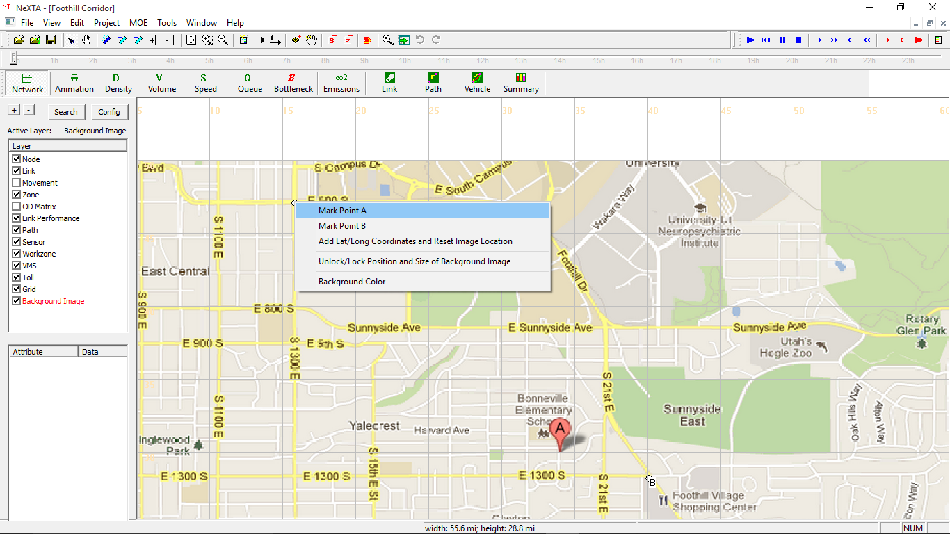

(iii) Select another known location on the background image, right-click and select "Mark point B" to locate the second point. This second point is recommended to be diagonally opposite (e.g., if Point A is in the top left corner, try to choose a location near the bottom right corner for Point B) and far away from Point A while still within the background image (longer distances between Point A and Point B reduce potential for distortion/flipped images). 1700 South and Foothill Drive is a good location for Point B, as shown below.

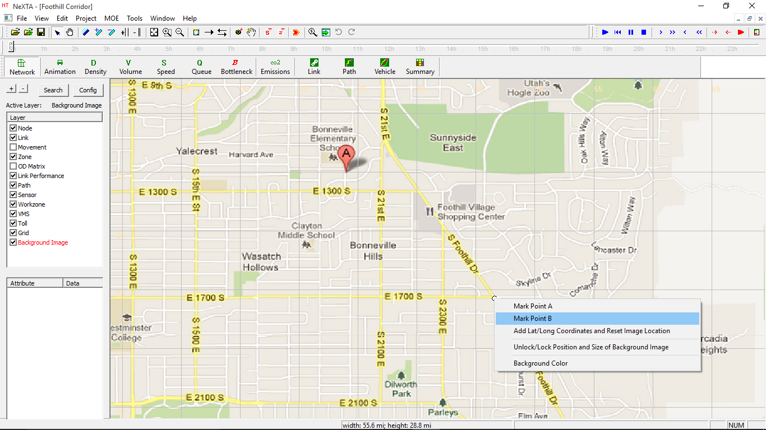

(iv) After creating Point A and Point B, right-click and select "Add Lat/long Coordinates and Reset Image Location".

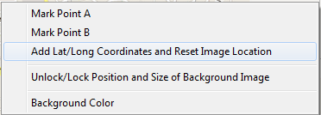

Now users need to input the corresponding Lat/long coordinates of the selected points in a dialog box.

To quickly find the lat/long coordinates of the selected points, you can click on 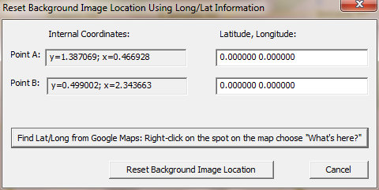, which will bring you to the Google Maps website.

Navigate to the location of Point A in Google Maps (in our case, 500 South and 1300 East in SLC), right-click the corresponding position on Google Maps and select “What’s here?”.

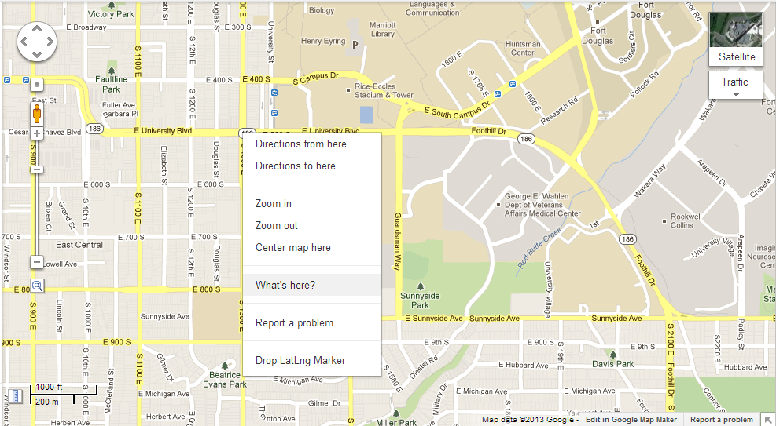

Copy and paste the lat/long coordinates in the dialog box for Point A. Perform the same procedure for Point B (navigate to location, use What’s here? tool to get lat/long coordinate, then copy/paste into dialog). Your dialog box should look like the image below (your coordinates may be different, depending on selected location). Your coordinates should not be very different unless you are working with a very large background image (50+ miles across)

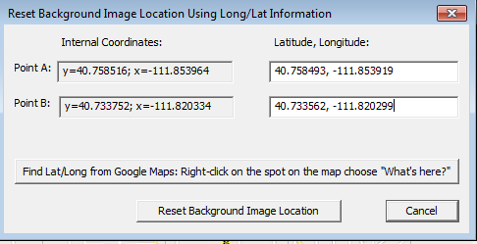

Click on the  button, and you should see the following loading status dialog after loading the project file.

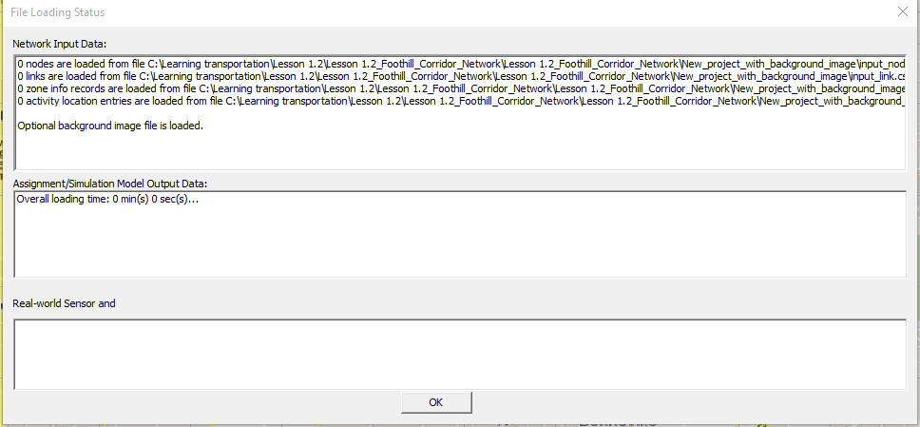

And click on ‘OK’ button, the background image will be fully loaded to the new long/lat position.

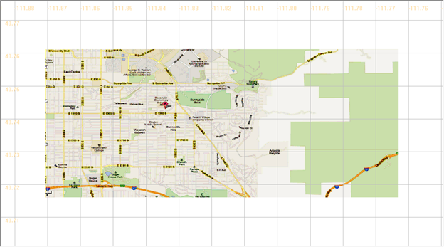

# Step 2: Create nodes and links for transportation network modeling

Related toolbar buttons: 

**Step 2.1:** Creating Links**.** There are a number of ways to create new links.

The first step is to set the default link properties in the Preferences dialog by clicking on  toggle button in the toolbar. Then confirm or change link type: speed limit: #of lanes.

In our Foothill example, please choose major arterial type.

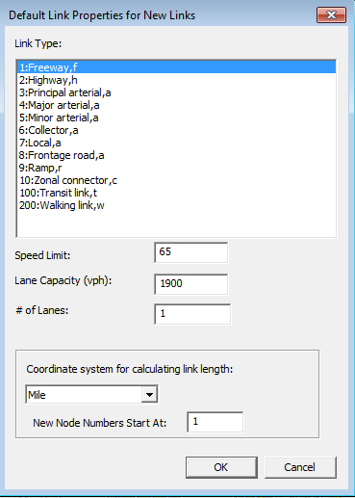

To create centroid nodes that typically start with large numbers, e.g. 50000, users can specify the input for “the new node numbers start at”. By default, new node numbers start from 1 and increase continuously.

The second step is to decide whether you want a single (one-way) link or a pair of links running in opposite directions. For a single link, press the Link toggle button. For a pair of opposing links, press the Two-Way Link toggle button.

The third step, after choosing single or double links, specify the start and end positions of the link(s). This can be done in two ways:

**A:** Click on the location you want the link to start. This can be on an existing node or where no node currently exists. Move the cursor to the desired end of the link. Now click on the location you want the link to end. Again, this can be on a node or not. A link will be created between these two locations.

**B:** Alternatively, you can press and hold the mouse button at the location you want the link to start. Keeping the button pressed, move the mouse to the location you want the link to end. Release the button and a link will be created between the two locations. If either endpoint does not already have a node, one will be created. If nodes already exist at the endpoints, the link will be connected to them.

**Step 2.2:** Creating Nodes**.** Press the Node  toggle button in the tool bar. Then point the cursor at the location where you want the node and click the left mouse button. You can continue creating nodes by clicking the left mouse button until you select a different toolbar button

A selected node can also be moved using the  button in the toolbar.

Nodes can be inserted into existing links. If a newly created node intersects an existing link, the link is broken into two links. 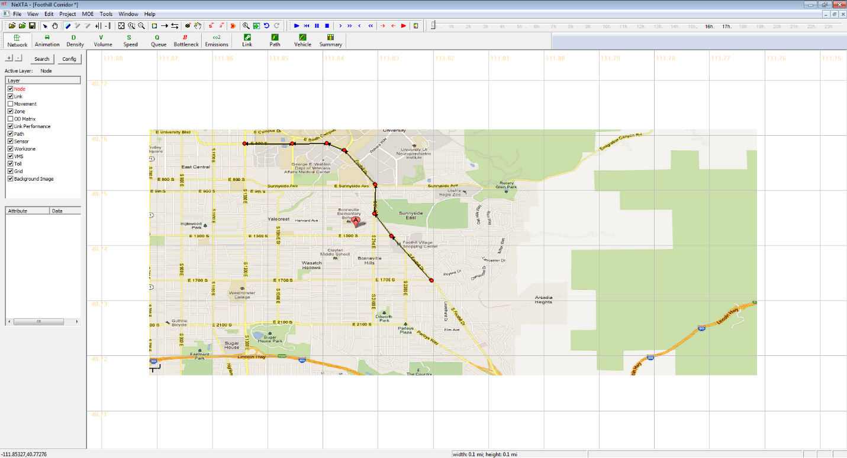

The new links are then automatically connected to the new node. The new links have the same properties as the existing link, except length, which is reset to default (node to node distance).

# Step 3 Familiar with GIS-layer based context menu

In this NEXTA interface, each GIS layer has its own right-click context menu , which offers a limited set of choices that are available in the current transportation GIS layer, e.g. node, link or zone layers. We now exploit a number of features on different layers.

**Step 3.1:** Click the 'Link' layer on the GIS layer panel, the corresponding layer becomes red when this layer is selected.

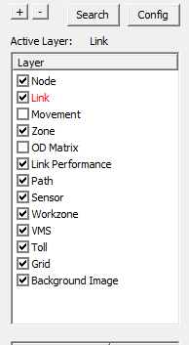

And left-click on one Link on the display view, and then right-click on one link on the display view to bring the following menu for link-related functions.

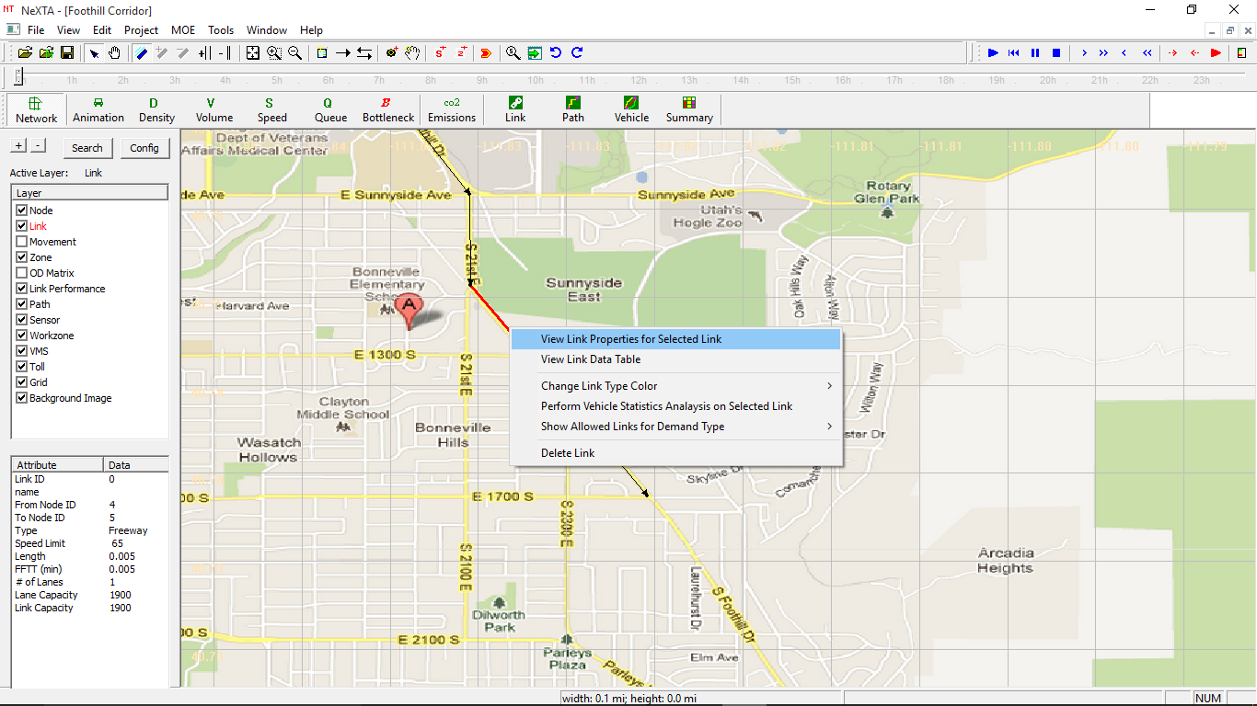

Click on  to see or change the detailed attributes of the selected link.

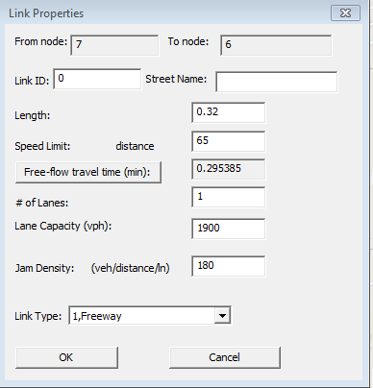

**Step 3.2:** Click the 'Node' layer on the GIS layer panel, the corresponding layer becomes red when this layer is selected. And left-click to select one Node on the display view, and then right-click to activate following menu for node-related functions.

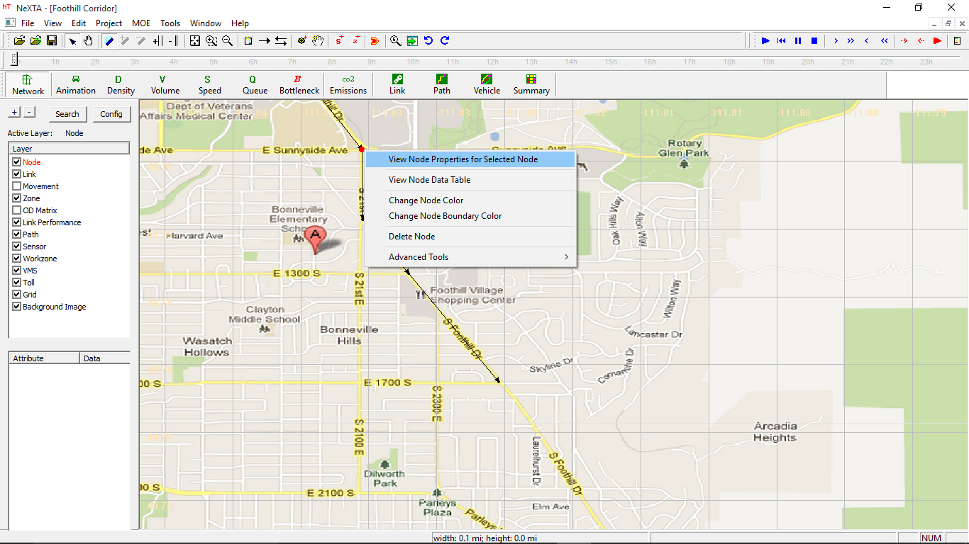

And Click on to see or change the detailed attributes of the selected Node.

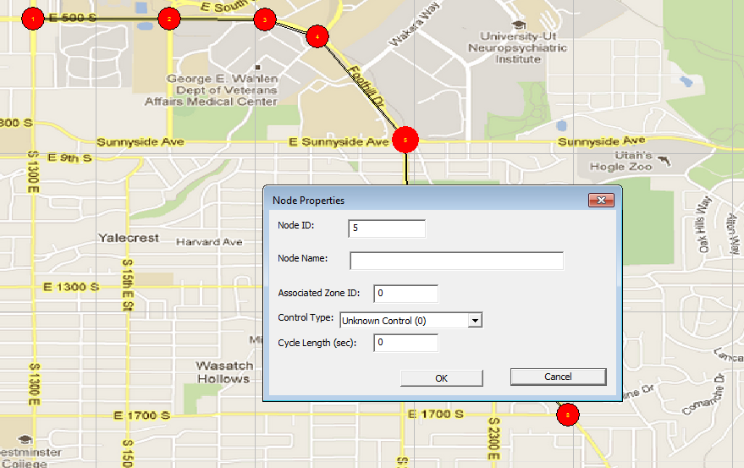

**Problem 1:**

(a) A rule of thumb is to code in roads one level below the level of interest for the study.

Please discuss why it is a good idea.

(b) Three basic items needed by a transportation model to determine impedance for the appropriate assignment of trips to the network are distance, speed, and capacity. What are the factors influencing free-flow link speeds and what data collection methods could be used to determine the free-flow speed? What are the factors resulting in the variation in per-lane capacity?

(c) How do we represent networks for different periods of the day that include operational changes, such as reversible lanes or peak-period HOV lanes?

(d) Why is important to have traffic count volume (where available) in network databases?

# 

# Step 4: Create zones and map activity locations

Related toolbar buttons: 

**Step 4.1:** click on , the cursor’s shape will become as.  Begin by clicking the mouse at a corner of the zone, A Feature Point will be created at that location. Move the mouse cursor to a new location and click again. A dashed line will be drawn to define the edge of the zone.  Repeat this process until the zone is complete. You can close the zone by double clicking the mouse anytime the zone will be defined by at least three points. Alternatively, you may move the mouse over the starting point and click to close the zone. When the zone is closed a zone number will appear centered in the zone.

|  |
| --- |
| **The rules of defining a zone number in NEXTA.**  If the zone boundary covers a node number, and this node will be defined as activity location and the corresponding node number will be used as the new zone number. By doing so, we can simplify the node-to-zone mapping. The DTALite/NEXTA package does not require sequentially increasing zone numbers.  If this zone number has been used (by another previously defined zones), then a new unused number greater than this value will be used.  If there are multiple nodes inside the zone boundary, then the smallest node number will be used. |

In this example, we create two zones to cover nodes 1 and 8.

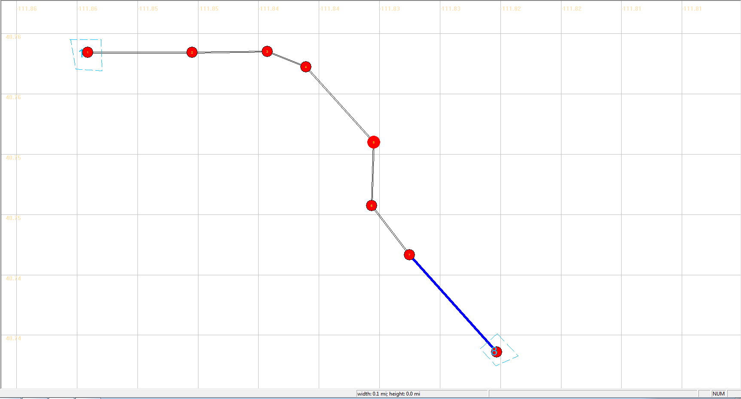

**Step 4.2:** And click the 'Zone' layer on the GIS layer panel,

On the display view, right-click on one Zone to bring the following context menu

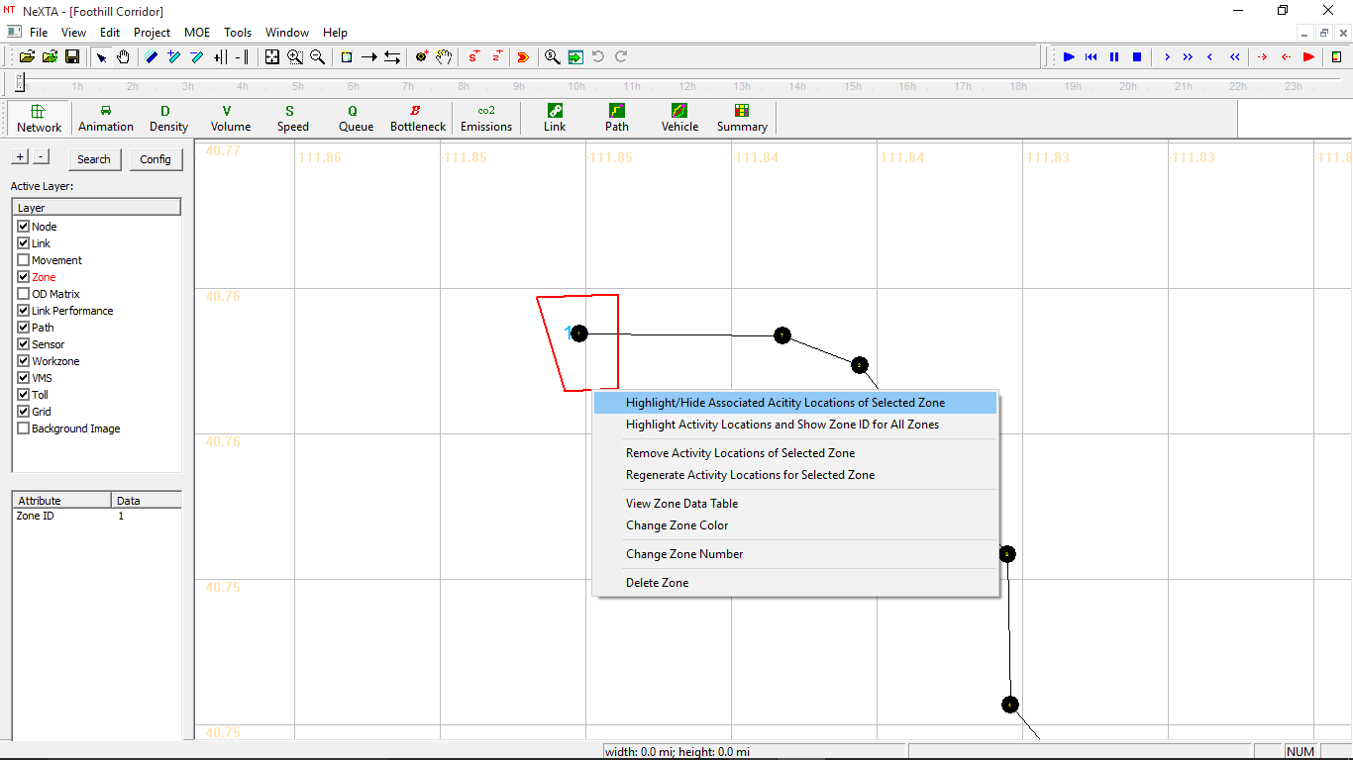

And check on menu“” to highlight/hide associated activity locations of selected zone.

Check on menu “” to view the detailed data of zone table.

Also you can go to the activity layer to view the related activity location table.

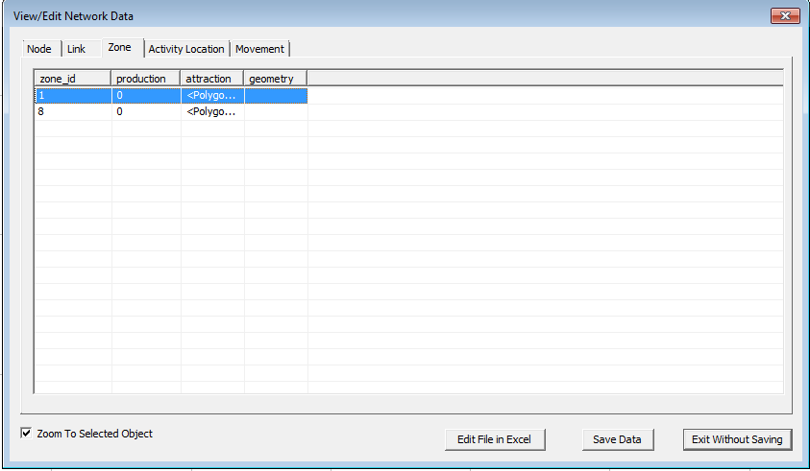

**Problem 2:**

(a) Please define the following terms: (i) Traffic Analysis Zones, (ii) centroid, (iii) centroid connector and (iv) external station.

(b) What are common components of TAZ boundaries? What are major criteria to be considered when establishing a zoning system?

(c) Please discuss the roles of zone centroids in modeling traffic. Please discuss how zone centroids and centers of activity are related with each other.

(d) Please discuss how TAZ boundaries might be affected by your study areas/topics, e.g. the TAZ structure in a subarea of particular interest may be denser than in other areas.

|  |
| --- |
| A zone can contain multiple activity locations, and an activity location can belong to multiple zones (defined in input_activity_location.csv). |

# Step 5: Create Demand Data for Traffic Simulation

**Step 5.1**: Copy the input_demand.csv and input_demand_file_list.csv from Sample_Project_Files folder into the New_Project_with_background_image folder. Now open the input_demand.csv file from the new project folder which will open in excel.

**Step 5.2:** As in this case, the zones were 1 and 8. Thus, the ‘from zone_id’ and ‘to zone_id’ will vary only from 1 to 8. Delete the rest of the zones from the input_demand.csv file. The excel file will look as follows:

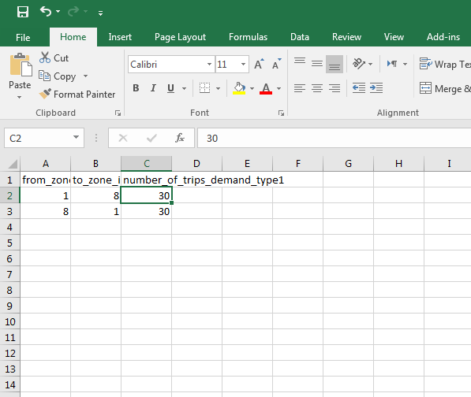

**Step 5.3:** Now open input_demand_file_list.csv to understand a few things from the file. It is used to define the characteristics of demand data. It consists of demand start and end time. It also consists of number of demand types which are stored in input_demand_type.csv and it is greater than or equal to 1. Input_demand_file_list is used to define the proportion of demand in the network as a function of time, which is used to initiate simulation.

# 

# Step 6: Define a path and check path travel time.

**Step 6.1:** Click the ‘Path' layer on the GIS layer panel.

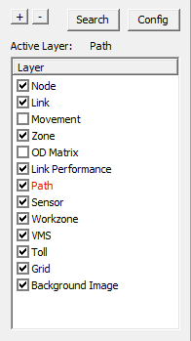

We now need to define the origin and destination to create a path.

First, right-click on a node on the display view to bring the following menu.

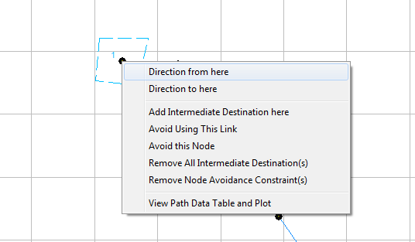

And check on menu“” to define the original point of a path. Right-click on another node, which you want to set as the destination, Check on menu “” to confirm this node as the endpoint of the path. You now see the path from the selected origin to selected destination.

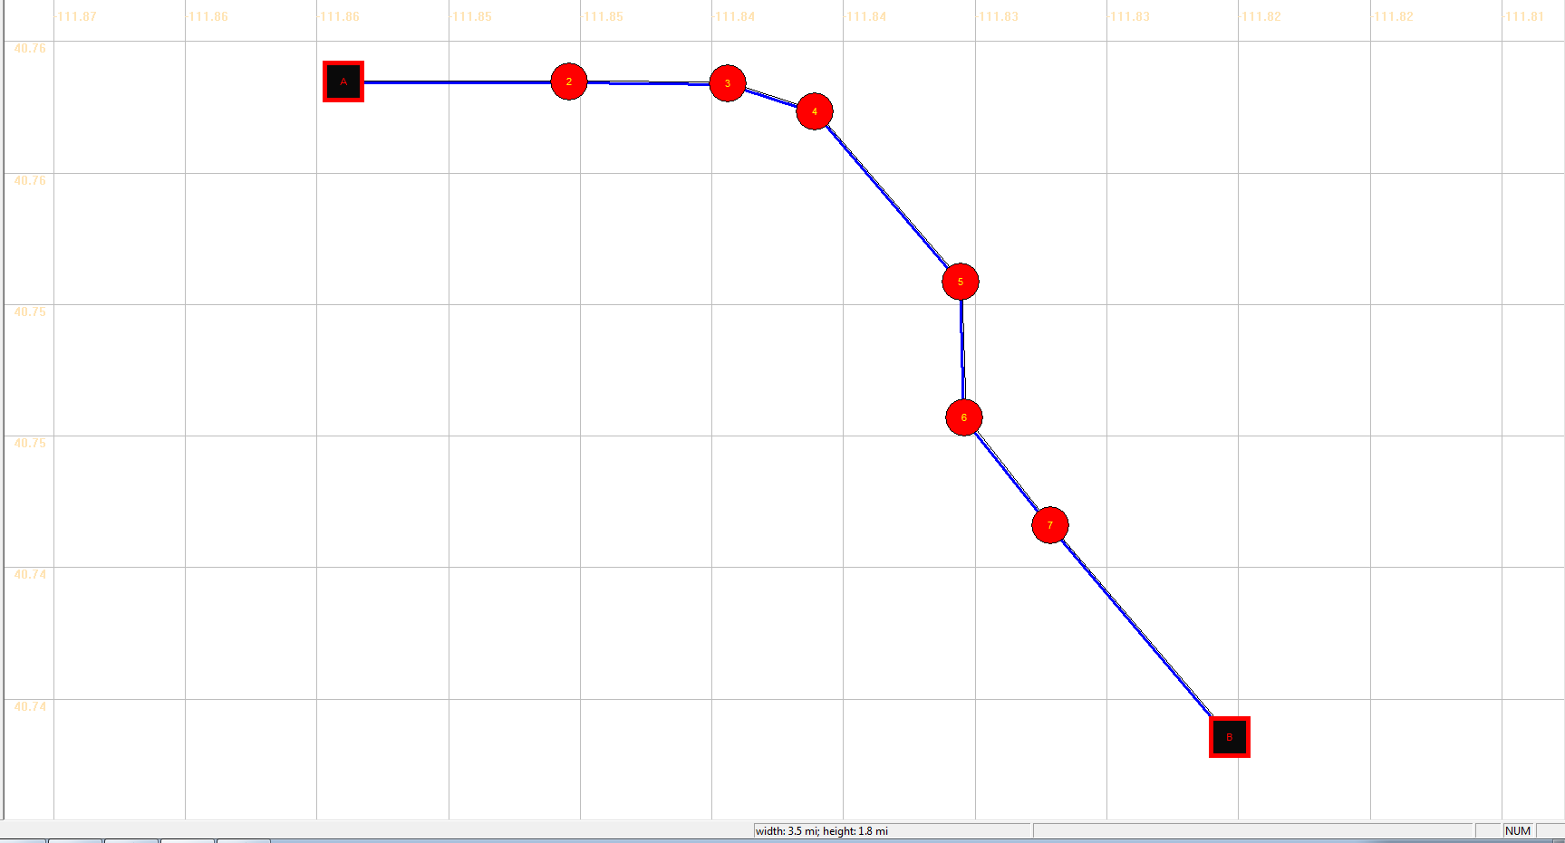

**Step 6.2:** Right-click on the path and select “” to view path information in a Path information Dialog. You can choose one path to see its information. Please check # of miles, path travel time (dependent on speed limit).

Also, open the input_link.csv to verify that you have the link lengths close to what the Google Maps display. Remember, the unit of length you selected in your project may differ from the unit of length on google maps. You can also change the length of your link by selecting link in the GIS layer panel 🡪 right-click on the link 🡪 length 🡪 changing the length to the most correct value you find from google maps.

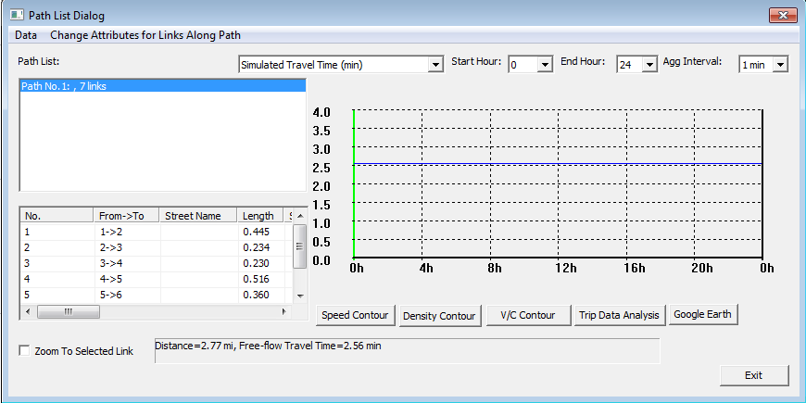

# 

# Step 7: Run static traffic assignment and find path travel time

Related toolbar: 

**Step 7.1:** Copy the input_scenario_settings from Sample_Project_Files folder and then click on to specify the detailed parameters of the simulation settings.

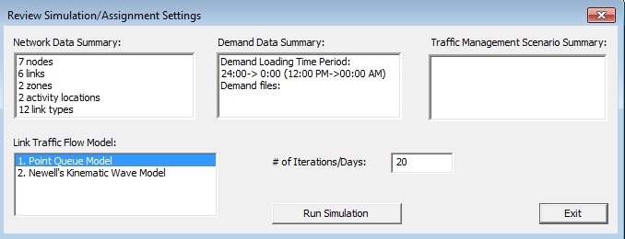

Please choose Point Queue Model and 20 # of iterations, click on ‘Run Simulation’ button to start simulation.

**Step 7.2:** Click on  button in the MOE tool bar to check the simulated data.

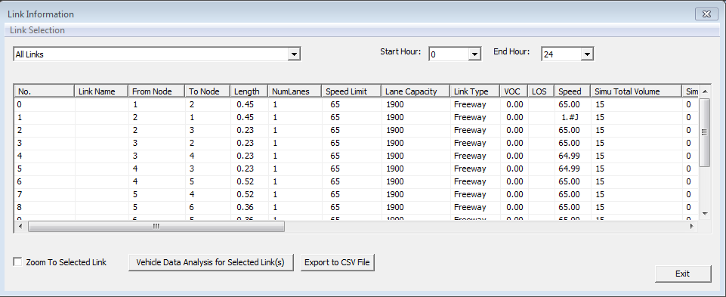

Click on  button in the MOE toolbar to activate the path information. dialog Please compare path free-flow travel time vs. simulated travel time with congestion in the path information Form.

Free-flow travel time:



Simulated travel time:

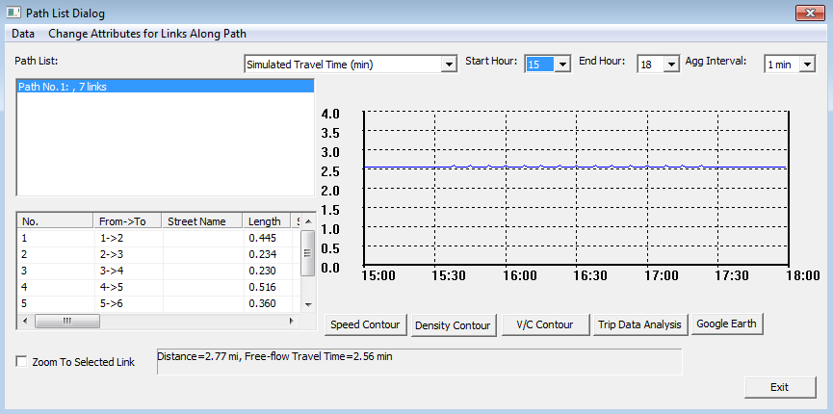

# 

# 

**Step 8: Check link MOE**

**Step 8.1:** Go to Link Performance layer

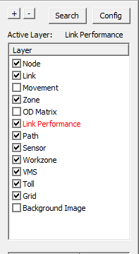

Right click on any one link to view link MOE summary list.

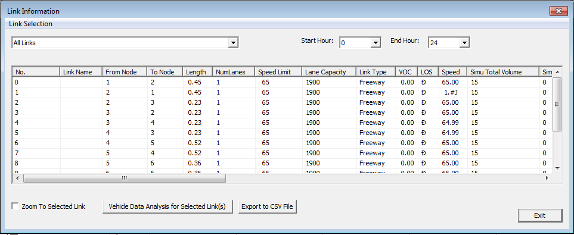

**Step 8.2:** Left-click on any link to get the MOE of any particular link.

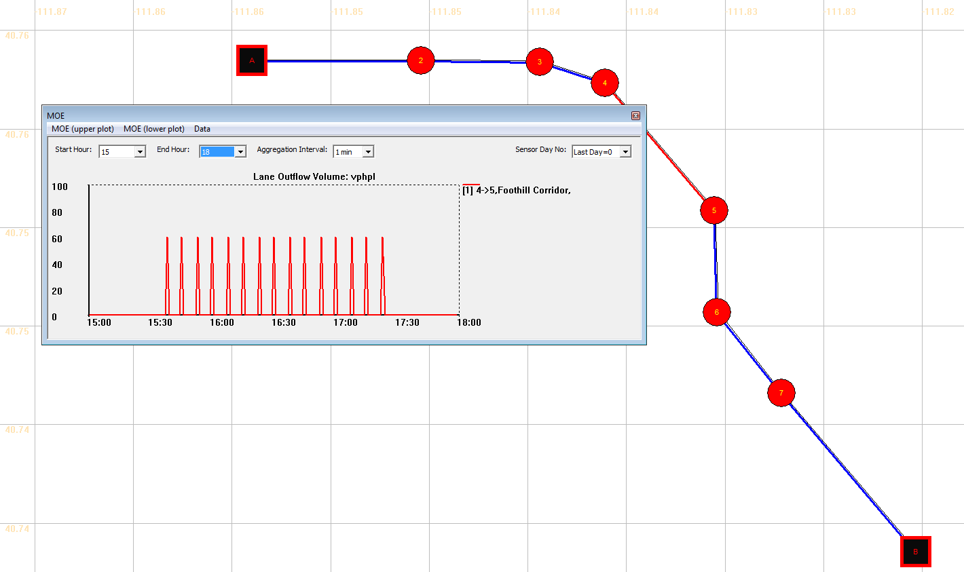

**Problem 3:**

Change the demand from input_demand file to 2000. Check the MOE. Does the MOE look the same as above? What is the reason of change in the pattern of MOE? (Hint: link capacity =1900)

Check time-dependent link MOE by clicking MOE in the menu-bar 🡪 Link MOE 🡪 Time-dependent Link MOE in Excel.

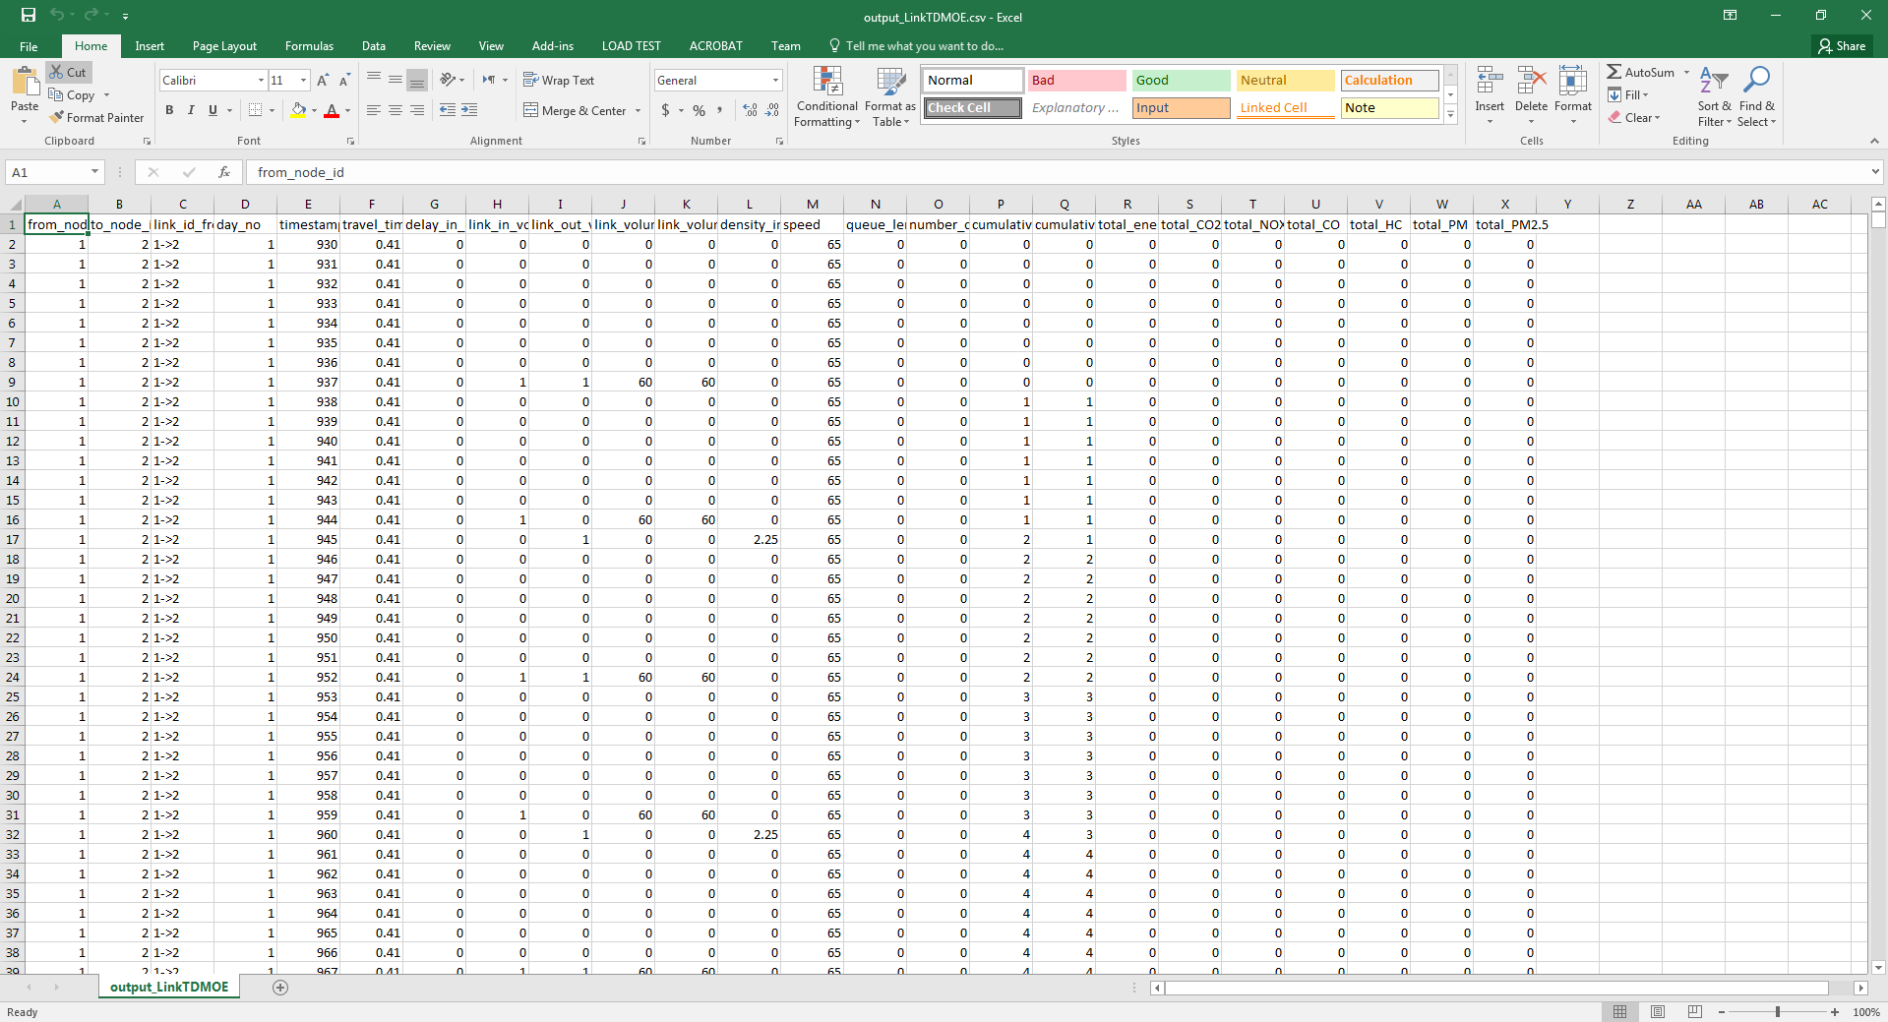

**Step 8.3:** Click on the  button in the MOE toolbar, and check data summary plot in the data summary dialog.

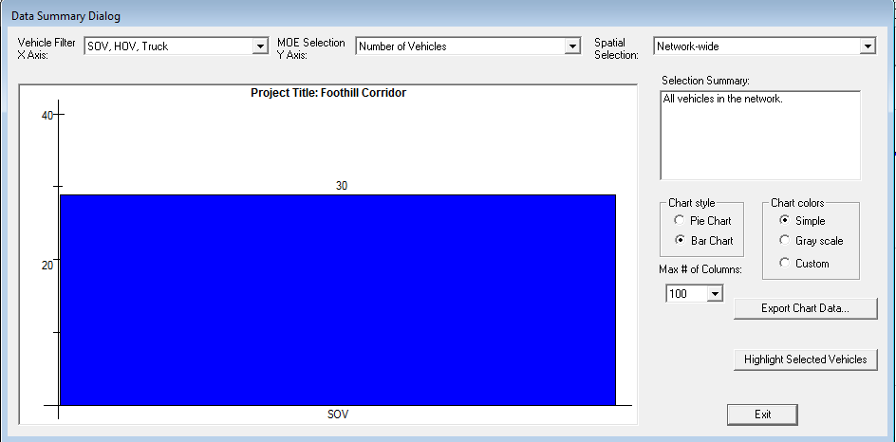

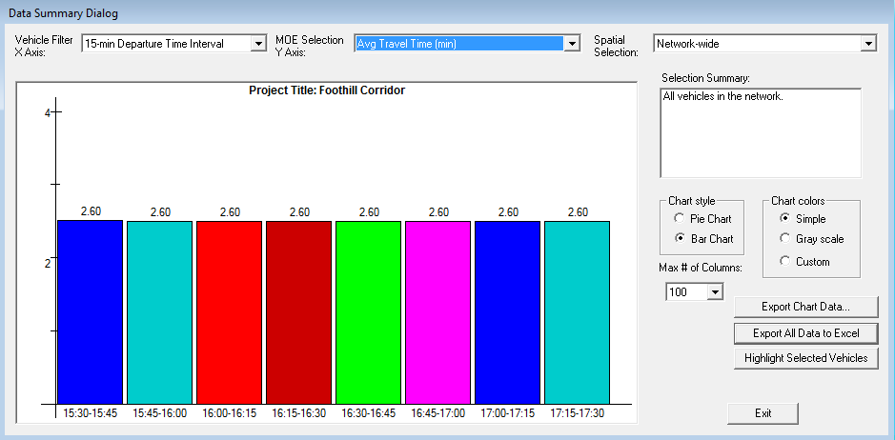

And click on  in the data summary dialog to export statistics data to excel file, check summary results in excel file.

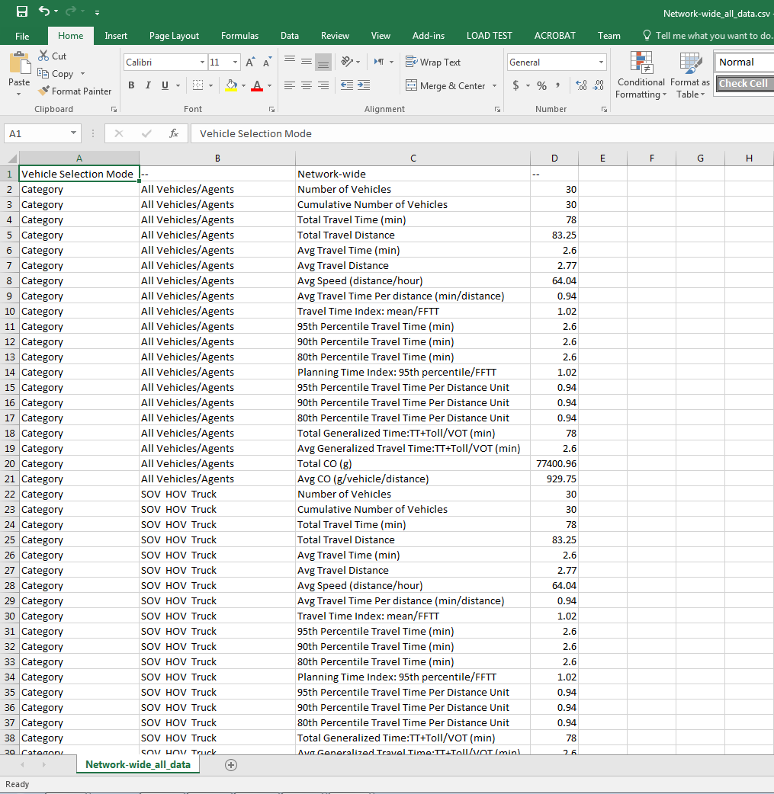

**Problem 4:**

Please compare the system wide travel time statistics using static traffic assignment and dynamic traffic assignment. The differences are due to different [traffic flow](http://en.wikipedia.org/wiki/Traffic_flow) modeling methods.

**Problem 5: Preparing Network files**

3

d

0.0

4000

a

e

4000

2

1

b

4000

c

0.0

4

(a) Please prepare the following tables to build the above network in static traffic analysis tools. You might need to use the default capacity, speed limit and number of lanes for each link type.

Node Table

|  |  |  |
| --- | --- | --- |
| **Node_id** | **x** | **y** |
|  |  |  |
|  |  |  |
|  |  |  |
|  |  |  |

Link Table

|  |  |  |  |  |  |  |
| --- | --- | --- | --- | --- | --- | --- |
| **from_node_id** | **to_node_id** | **length** | **number_of_lanes** | **speed_limit** | **capacity** | **link_type** |
|  |  |  |  |  |  |  |
|  |  |  |  |  |  |  |
|  |  |  |  |  |  |  |

Zone to Activity Location Mapping Table (TAZ: Traffic Analysis Zone). In this table, we describe the relationship between a zone and associated activity locations. For example, zone covers node 1 and zone 2 covers node 2, as shown below:

|  |  |
| --- | --- |
| **taz** | **Node­_id** |
| 1 | 1 |
| 2 | 2 |

(b) How many feasible paths are available from node 1 to node 4?

(c) What is the shortest distance from node 1 to node 4?

What is the least travel time from node 1 to node 4?

(d) Please draw such a network in NeXTA and compare your above input data with automatically generated data in files input_node.csv, input_link.csv, input_zone.csv, input_activity_location.csv, which are located in the project folder. You can also go to menu->Project->1. network data, and click on the corresponding tab, and select “Edit File In Excel” to see the related file.

# 